Question 1

N = $N_{3} N_{2} N_{1} N_{0}$

 |  |  |  | $$N_{3}$$ | $$N_{2}$$ | $$N_{1}$$ | $$N_{0}$$
 |  |  |  | $$N_{3}$$ | $$N_{2}$$ | $$N_{1}$$ | $$N_{0}$$
 |  |  |  | $$N_{0}N_{3}$$ | $$N_{0}N_{2}$$ | $$N_{0}N_{1}$$ | $$N_{0}N_{0}$$
 |  |  | $$N_{1}N_{3}$$ | $$N_{1}N_{2}$$ | $$N_{1}N_{1}$$ | $$N_{1}N_{0}$$
 |  | $$N_{2}N_{3}$$ | $$N_{2}N_{2}$$ | $$N_{2}N_{1}$$ | $$N_{2}N_{0}$$
 | $$N_{3}N_{3}$$ | $$N_{3}N_{2}$$ | $$N_{3}N_{1}$$ | $$N_{3}N_{0}$$
 | $$N_{3}N_{2}$$ | $$N_{1}N_{3}$$ | $$N_{0}N_{3}$$ | $$N_{0}N_{2}$$ | $$N_{1}N_{0}$$ | 0 | $$N_{0}$$ | 0 | $$←2N^{2}$$
 | $$N_{3}$$ |  | $$N_{2}N_{1}$$ |  | $$N_{1}$$
 |  |  | $$N_{2}$$
 |  |  |  |  |  |  |  | 1 | $$←+1$$
 | $$N_{3}N_{2}$$ | $$N_{1}N_{3}$$ | $$N_{0}N_{3}$$ | $$N_{0}N_{2}$$ | $$N_{1}N_{0}$$ | 0 | $$N_{0}$$ | 1
 | $$N_{3}$$ |  | $$N_{2}N_{1}$$ |  | $$N_{1}$$
 |  |  | $$N_{2}$$ |  |  |  |  | $$m_{i} m_{j}$$

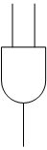

$$N_{2}N_{1}$$

$$N_{0}N_{3}$$

$$N_{0}N_{2}$$

$$1$$

$$N_{0}$$

$$0$$

$$N_{1}$$
$$N_{1}N_{0}$$

FA
HA
HA

$$N_{3}$$
$$N_{1}N_{3}$$

HA
FA
FA
$$N_{3}N_{2}$$

$$N_{2}$$

$$P_{0}$$
$$P_{8}$$
$$P_{7}$$
$$P_{6}$$
$$P_{4}$$
$$P_{5}$$
$$P_{3}$$
$$P_{2}$$
$$P_{1}$$

N = ${1011}_{2}=11$
$$2N^{2}+1=243$$

$$1$$

$$0$$
1
$$0$$
$$1$$

$$1$$
$$0$$

1

FA
HA
HA

0
$$1$$
$$0$$
$$1$$

HA
FA
FA

$$1$$
$$0$$
$$1$$
$$1$$
$$1$$
$$1$$
$$0$$
$$0$$
$$1$$

$$128+64+32+16+2+1=243$$

Question 2

This implementation can be done in several ways, in terms of how to divide the 8-bit. Below we give implementation by using two 4-bit Carry Skip Adder.

$$C_{1}$$
$$C_{in}$$
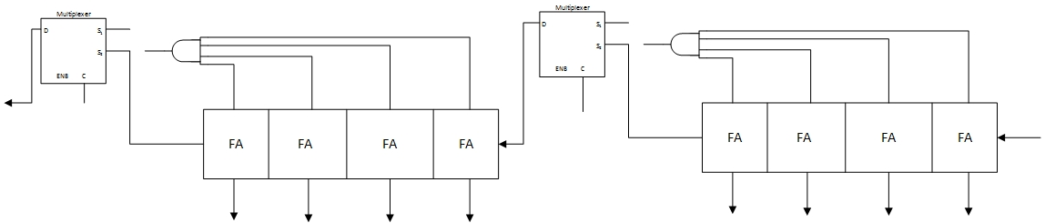
$$B_{0}-B_{3}$$
$$A_{0}-A_{3}$$
$$P_{2}$$
$$P_{1}$$
$$S_{7}$$
$$S_{6}$$
$$S_{5}$$
$$S_{0}$$
$$S_{1}$$
$$S_{2}$$
$$S_{3}$$
$$S_{4}$$
$$P_{2}$$
$$P_{1}$$
$$C_{out}$$
$$P_{7}$$
$$P_{6}$$
$$P_{0}$$
$$P_{1}$$
$$P_{2}$$
$$P_{3}$$
$$P_{4}$$
$$P_{5}$$
$$C_{in}$$

$$Critical path Carry Skip=8*τ_{FA}+2*τ_{AND}+2*τ_{MUX} =8*3τ_{gate}+2τ_{gate}+3*2τ_{gate}=32τ_{gate}$$
$$Critical path Carry Ripple=8*τ_{FA} =8*3τ_{gate}=24τ_{gate}$$

$$Area of Carry Skip=8*A_{FA}+2 A_{AND}+2 A_{MUX} =8*5A_{gate}+2A_{gate}+2*3A_{gate}=48A_{gate}$$
$$Area of Carry Ripple=8*A_{FA}=8*5A_{gate}=40A_{gate}$$

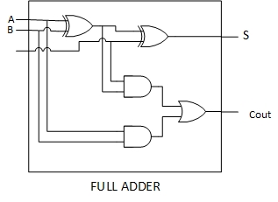
$$Delay=3τ_{gate}$$
$$Area=5A_{gate}$$

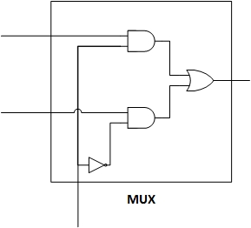
$$Delay=3τ_{gate}$$
$$Area=4A_{gate}$$
Neglect inverter

Question 3

Present State |  |  |  | Next State
$$y_{3}$$ | $$y_{2}$$ | $$y_{1}$$ |  | $$y_{3}^{+}$$ | $$y_{2}^{+}$$ | $$y_{1}^{+}$$
0 | 0 | 0 |  | 0 | 0 | 0
0 | 0 | 1 |  | 0 | 0 | 0
0 | 1 | 0 |  | 0 | 0 | 1
0 | 1 | 1 |  | 0 | 0 | 1
1 | 0 | 0 |  | 0 | 1 | 0
1 | 0 | 1 |  | 0 | 1 | 0
1 | 1 | 0 |  | 0 | 1 | 1
1 | 1 | 1 |  | 0 | 1 | 1
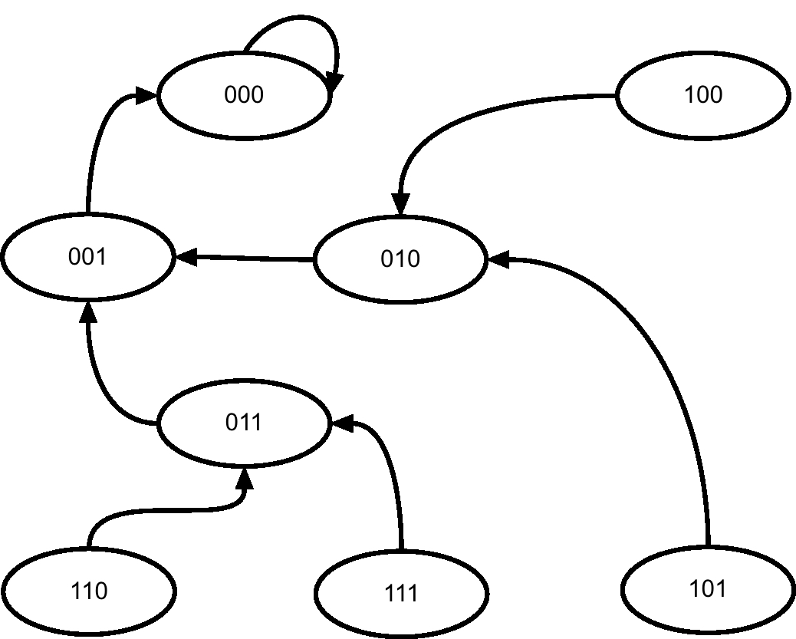

$y_{3}$ $y_{2}y_{1}$ | 00 | 01 | 11 | 10
0 | 0 | 0 | 1 | 1
1 | 0 | 0 | 1 | 1

$$y_{1}^{+}=y_{2}=D_{1}$$

$y_{3}$ $y_{2}y_{1}$ | 00 | 01 | 11 | 10
0 | 0 | 0 | 0 | 0
1 | 1 | 1 | 1 | 1

$$y_{2}^{+}=y_{3}=D_{2}$$

$y_{3}$ $y_{2}y_{1}$ | 00 | 01 | 11 | 10
0 | 0 | 0 | 0 | 0
1 | 0 | 0 | 0 | 0

$$y_{3}^{+}=0=D_{3}$$
Using D Flip Flop:
$$y_{3}^{+}=0=D_{3}$$
$$y_{2}^{+}=y_{3}=D_{2}$$
$$y_{1}^{+}=y_{2}=D_{1}$$
CLK
$$y_{1}$$
$$y_{2}$$
$$y_{3}$$
0
$$D_{1}$$
$$D_{2}$$
$$D_{3}$$

